**TRIBHUWAN UNIVERSITY**

Institute of Engineering

Pulchowk Campus, Lalitpur

Project Report

“I N F I N I T Y”

*(Equation Solver & Statistical Analyzer in C programming language)*

**Submitted by:**  **Submitted to:**

Prabin Lamichhane (074BCT523) The Department of Electronics

Kritan Banstola (074BCT516) and Computer Engineering

Aman Kumar Gupta (074BCT503)

**Acknowledgement**

All the praises are for the world that wishes to see individuals like us grow doing projects like these. We would like to thank our purposeful teacher Mr. Sudarshan Sharma. His wonderful guiding through the course has made us able to reach the deadline of the submission successfully. Department of Electronics and Computer Engineering deserve appreciation for the conduction of effective management. World today will feel this writing incomplete without the inclusion of well-developed online network that provides help at every trouble encountered on our journey towards the extremity. Seniors of our department are also part of our success whose creditable teachings helped us manage our codes in the best possible way. Our affable class’s supportive response on our project had provided us motivation to complete the project. Last but not the least, gratitude to our family for all their unconditional love and care.

**Abstract**

Program built helps in the analysis of numerical problems. The program can solve infinite number of linear and polynomial equation. The application of correlation in the program will provide assistance in finding the best possible line for your equation. Standard deviation helps use to find the consistency of the data taken and determine the error. Solution of matrix problems can also be overcome making the use of program. A section of history in the program keeps the track of all the operations you have made.

***Keywords:*** *linear equation, polynomial equation, correlation, standard deviation, matrix, history.*

**Introduction**

The statistics analyzers have always been popular among the researchers and experimenters. The data obtained from the performances are not so easy to analyze. Lots of calculations need to be performed and simple mistake can break the flow of your accuracy. So, programs like these are for sure helpful in calculation over the data.

The problem that we encountered while performing our practical gave us the inspiration to develop the program that we can use widely in the wide field of practical and research. This simple program will help user skip the tedious mathematical operations that are easy to perform but difficult to manage effectively. The track of operation performed in the past would also help skipping the writing portion to keep the track of the calculations made.

The technical terms used basically in the program that you need to understand are described below:

* **Linear Equation**

An equation in algebraic form where the terms are either constants or the product of constant and (first power of) variable is called Linear Equation.

Illustration: 1x + 2y + 3z = 0, 1z + 2k + 6 = 0 etc.

* **Polynomial equation**

In mathematics, a polynomial is an expression consisting of variables (also called indeterminate) and coefficients that involve only the operation of addition, subtraction, multiplication, and non-negative integer exponents of variables.

Illustration: anxn + an-1xn-1 + … … + a2x2 + a1x1 + a0

wherea0 ….. an are constants and x is indeterminate.

Note: This program can solve equations having non-integer powers as well.

* **Correlation**

Correlation of data is any of a broad class of statistical relationship involving dependencies among the data. The understanding of correlation can be understood form scatter diagram.

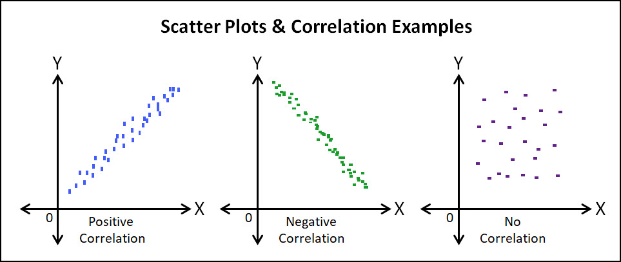

**Positive Correlation:** Both variables move in the same direction. In other words, as one variable increases, the other variable also increases. As one variable decreases, the other variable also decreases.

Example: The years you have lived and your age.

**Negative Correlation:** The variables move in opposite directions. As one variable increases, the other variable decreases. As one variable decreases, the other variable increases.

Example: The hours in a day you sleep and the hours in day you work.

* **Standard Deviation**

In statistics, Standard Deviation is a measure that is used to quantify the amount of variation or dispersion of a set of data values. A low standard deviation indicates that the data points tend to be close to the mean of the set, while a high standard deviation indicates that the data points are spread out over a wider range of values.

**Past works on the projects:**

The program developed under the C programming language in not a new concept. Previously, numerous program have been built in C as well as many other languages. The programs are also in wide use at almost all the levels. Data finder form simple school labs to high lever research centers are using such applications to reduce the time consumption and gain accuracy over the calculation. The interpretation of action performed also becomes easier with the use of applications like these. Programs like these are wonderful outcome of good mathematics and proper programming implementation.

**Objectives**

The developers of the program have expected that the program fulfills the following assumed objectives:

* Preparation of the data in a format it can be processed and manipulated.

Various methods have been used to arrange the input data in a format it can be processed. The input parameters are somewhere stored in multidimensional arrays and serial operations have been performed on them. Some use of structures has been made to store the input.

* Descriptive analysis

This field of our program is primarily targeted at the display of the operated results or any input parameters in tabular form so that the user of the program catches the working of the program with an ease. Summary tables contribute a major part of this objective. Formatted outputs helped us reach the milestone.

* Confirmatory analysis

The measure of precision adopted in the program is built upon the objective of confirmatory analysis. Our calculation of results and errors can be assumed to be under this objective. Pre-defined as well as self-defined mathematical functions were used.

* Retain previous calculations

The program is designed to assist the user in keeping the history of all the operations that s/he had performed in the past. Meeting the objective was made possible by the use of file handling in C.

**Methodologies**

**Future Enhancements**

The program is supposed to be extendable to a level where it can serve greater amount of the helps to the users of the program. Short time duration had a great impact over our project. We would like to intensify our project by adding features like graph plotter, upgrading the user interface, adding newer measures of data analysis, adding measures to share the calculations on platforms of networking etc. We would be pleased to work further on the development of the project.

**References**

Baral, D. S., Baral, D., & Ghimire, S. K. (2008). *The Secrets of C Programming Language.* Kathmandu, Nepal: Phudipuran Prakashan.

Kanetkar, Y. (2017). *Let us C (15th Edition).* Mumbai, India: BPB Publication.

Kumar, A., Singh, A., & Anand, R. (2016). *C introduction: Learn and Compile C codes*. Retrieved 2017, from CodesDope: www.codesdope.com